A)Match the following pictures with the correct names of people fundamental for The Turkish Natıon.

1)

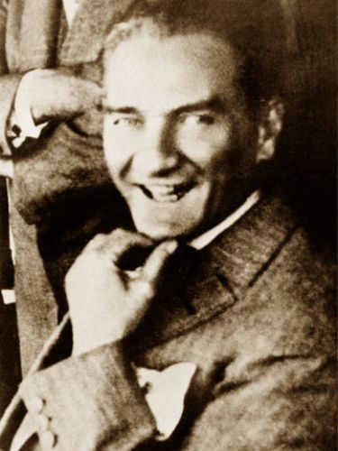

a)Mevlana

b)Mustafa Kemal ATATÜRK

c)Fatih TERİM

d)Hidayet TÜRKOĞLU

( correct answer: B )

2)

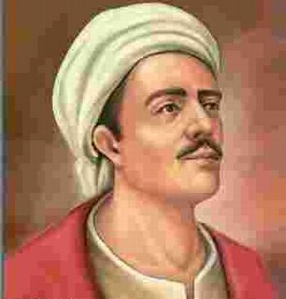

a)Mevlana

b)Yaşar KEMAL

c)Yunus Emre

d)Gazali

( correct answer: C )

3)

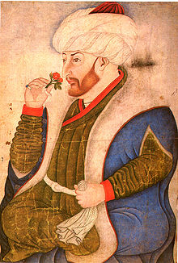

a)Fatih Sultan Mehmet

b)Kanuni Sultan Süleyman

c)Yavuz Sultan Selim

d)Osman Bey

( correct answer:A)

4)

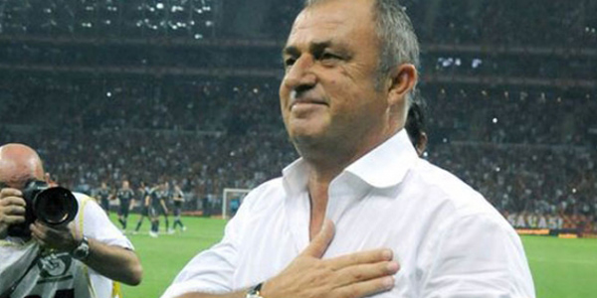

a)Arda TURAN

b)Emre BELÖZOĞLU

c)Yıldıray BAŞTÜRK

d)Fatih TERİM

( correct answer: D)

5)

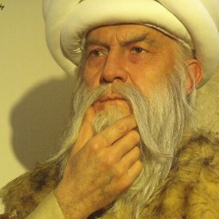

a)Fuzuli

b)Itri

c) Mimar Sinan

d)El-Cezeri

( correct answer: C )

B.MATCH THE FOLLOWING BOOKS WITH THEIR WRITERS.

1.Kutadgu Bilig

a. Mevlana b. Fuzuli c. İbni Sina d. Yusuf Has Hacip

correct answer: d

2. Mesnevi

a. Mevlana b. Fuzuli c. İbni Sina d. Yusuf Has Hacip

correct answer: a

3. Safahat

a. Mevlana b. Fuzuli c. İbni Sina d. Mehmet Akif Ersoy

correct answer: d

4. El Kanun fit Tıb

a. Mevlana b. Fuzuli c. İbni Sina d. Mehmet Akif Ersoy

correct answer:c

5. Şikayetname

a. Mevlana b. Fuzuli c. İbni Sina d. Mehmet Akif Ersoy

correct answer:b

C. Match the following pictures with the correct names of food

1)

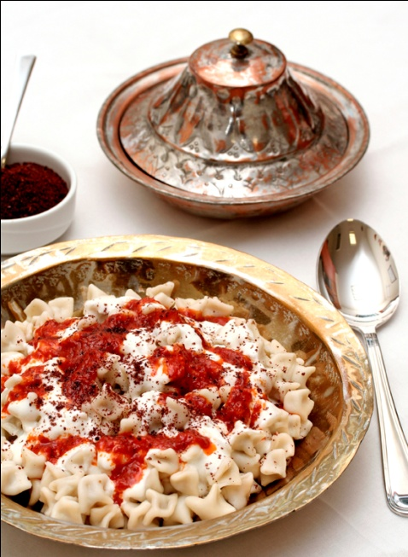

a)İçli Köfte

b)Tarhana Çorbası

c)Mantı

d)Yaprak Sarması

( correct answer: C )

2)

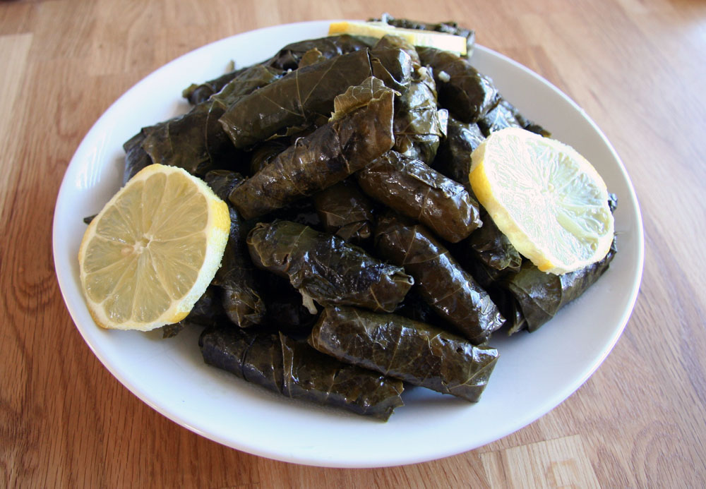

a)Güveç

b)Yaprak Sarması(Wine Leaves)

c)Kebap

d)Düğün Pilavı

( correct answer: B)

3)

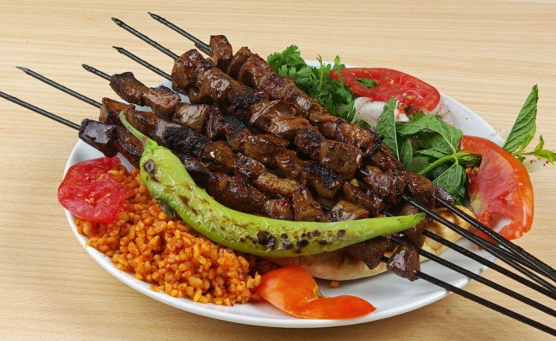

a)Şiş Kebap

b)Mercimek Çorbası

c)Mantı

d)Kısır

( correct answer: A)

4)

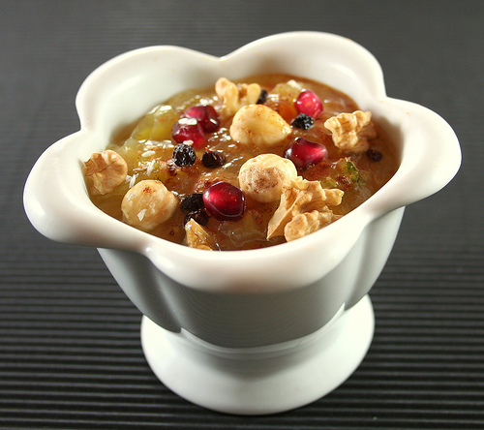

a)Baklava

b)Sütlaç

c)Kazandibi

d)Aşure

( correct answer:D)

5)

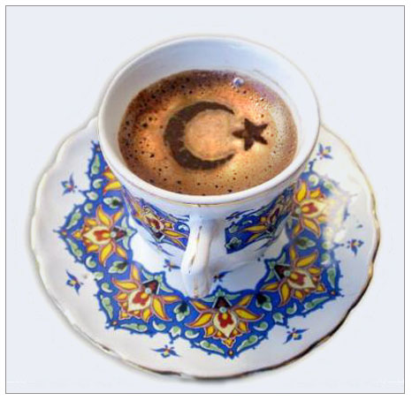

a)Kızılcık Şerbeti

b)Çay

c)Turkish coffee

d)Papatya Çayı

correct answer: c

D. Match the following inventions with the correct names of fundamental inventor for The Turkish Natıon.

1. 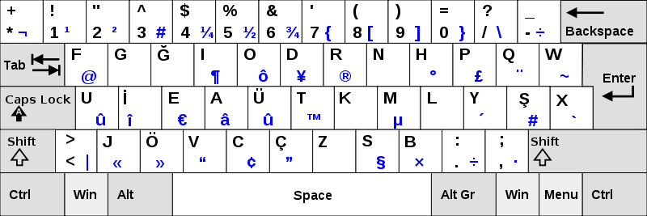(THE F KEYBOARD)

a.Piri Reis b.Ali Kuscu c.Ulug Bey d.Ihsan Sitki Yener

Correct Answer:d

2. 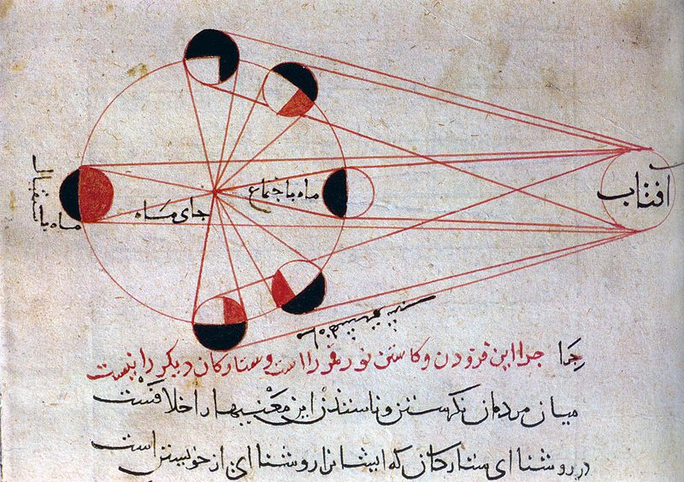an alternativeplanetary model for Mercury

a.Ali Kuscu b.Ulug Bey c.El Bruni d.Piri Reis

correct answer:a

3. 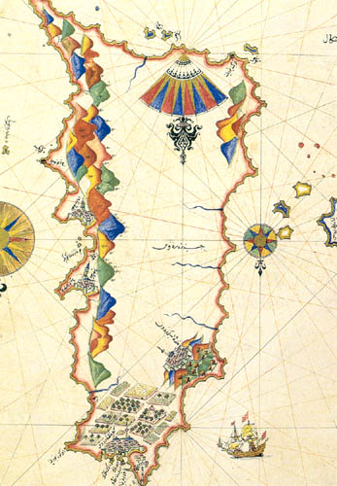Worl Map –Book of Navigation

a.Ali Kuscu b.Piri Reis c.Ulug Bey d.El Bruni

correct answer b

4. 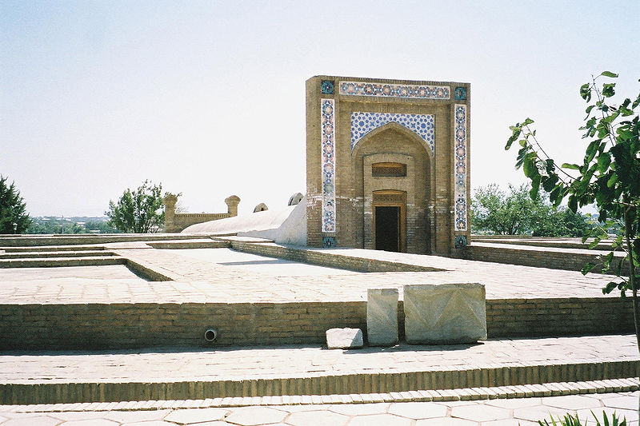Observatory of Zeyc Kurkani

a.Piri Reis b.Ulug Bey c.Ali Kuscu d.El Bruni

correct answer b

5. Founder of experimental astronomy

a.Piri Reis b.Ulug Bey c.Ali Kuscu d.El Bruni

correct answer : d

E. Match the following pictures with the correct names of historical places.

1)

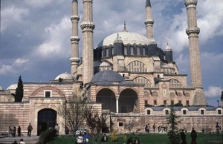

a)Selimiye Camii

b)Galata Kulesi

c)Kız Kalesi

d)Kilise

( correct answer:A)

2)

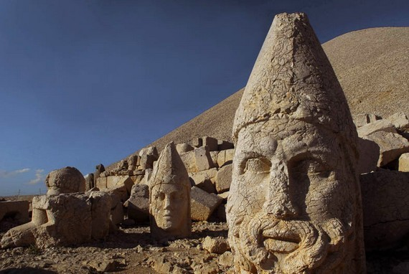

a)Topkapı Sarayı

b)Uludağ

c)Cennet Cehennem Mağaraları

d)Nemrut Mountain

( correct answer: D)

3)

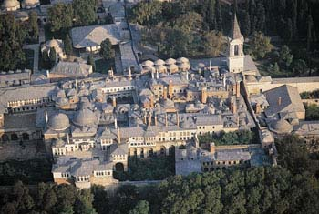

a)Ankara kalesi

b)Topkapı Palace

c)Kız Kulesi

d)Olimpos

( correct answer: B)

4)

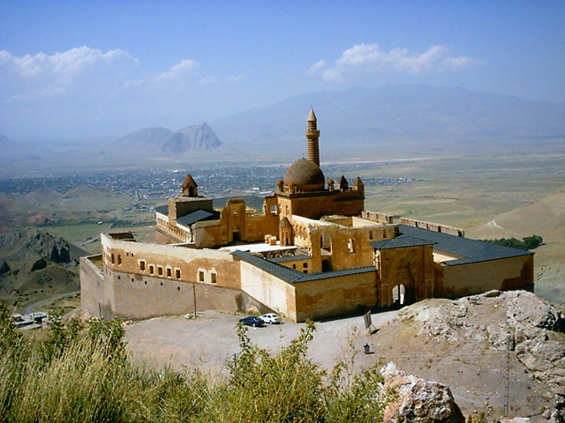

a)Çırağan Sarayı

b)Dolmabahçe Sarayı

c)Yerebatan Sarnıcı

d)İshak Paşa Palace

( correct answer:D)

5)

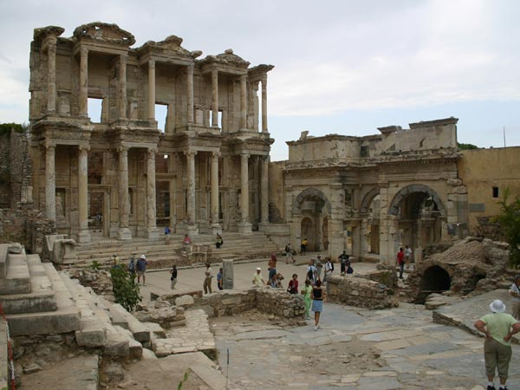

a)Efes Antik Kenti (Ephesos Ancient City)

b)Bergama

c)Aspendos

d)Sümela Manastırı (correct answer: A)

F. MATCH THE FOLLOWING TOWNs WITH THEIR CITIES

1)Güdül a)Antalya

2)Bodrum b)Ankara

3)Kaş c)Muğla

4)Taksim d)Aydın

5)Kuşadası e)İstanbul

( correct answers: 1-b,2-c,3-a,4-e,5-d)

G. MATCH THE FOLLOWING PICTURE SWITH CORRECT NAMES OF FESTIVALS

1)

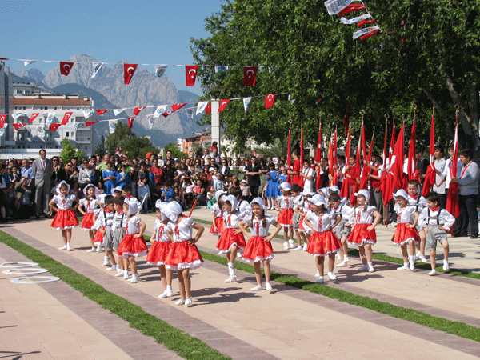

a)30 Ağustos Zafer Bayramı

b)23 Nisan Ulusal Egemenlik ve Çocuk Bayramı(Children Day)

c)19 Mayıs Gençlik Ve Spor bayramı

d)29 Ekim Cumhuriyet Bayramı

( correct answer: B)

2)

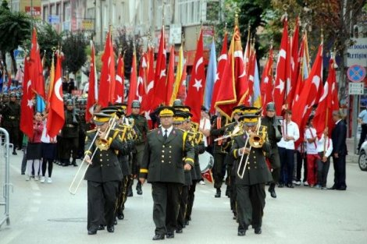

a)30 Ağustos Zafer Bayramı (Victory Day)

b)23 Nisan Ulusal Egemenlik ve Çocuk Bayramı(Children’s day)

c)19 Mayıs Gençlik Ve Spor bayramı(Youth Day)

d)29 Ekim Cumhuriyet Bayramı(Independence Day)

(correct answer:A)

3)

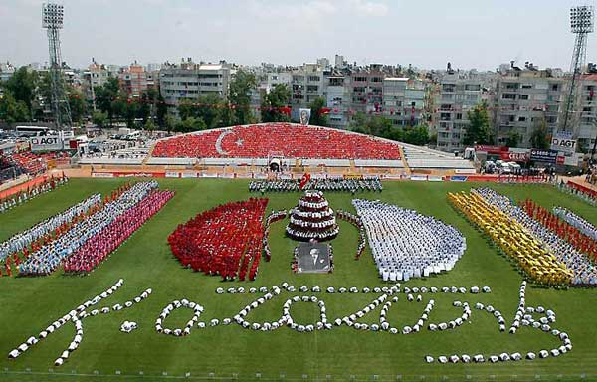

a)1 Mayıs İşçi Bayramı(Workers’ day)

b)24 Kasım Öğretmenler Günü(Teachers’ Day)

c)19 Mayıs Gençlik ve Spor Bayramı (Youth Day)

d) 29 Ekim Cumhuriyet Bayramı(Independence day)

(correct answer: C)

4)

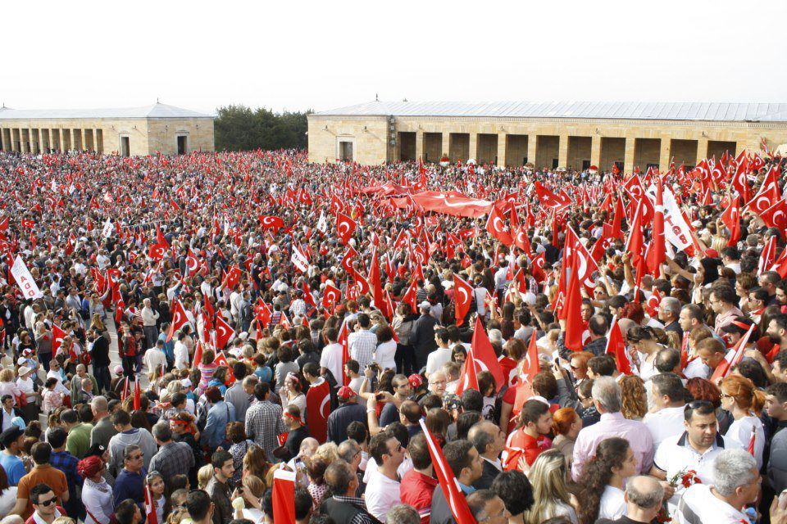

a) 23 Nisan Ulusal Egemenlik ve Çocuk Bayramı(Children’s Day)

b)19 Mayıs Gençlik Ve Spor bayramı(Youth Day)

c) 30 Ağustos Zafer Bayramı(Victory Day)

d)29 Ekim Cumhuriyet Bayramı (Republic Day)

( correct answer:D)

5)

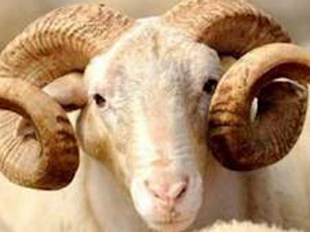

a)Ramazan Bayramı (Ramadan Festiva)

b)Kurban Bayramı (Religious Festival)

c)Mevlit Kandili

d)Kadir Gecesi

( correct answer: B)